MAJOR PROJECT REPORT

(Submitted in partial fulfilment of the Degree of B.Sc. IT under the
Assam Science and Technology University, Assam)

Title of the Project
JEWELLERY MANAGEMENT SYSTEM

Submitted by
Name of the Candidate : Sumeet Bharali
Registration No.:
Roll No.:

Supervised by
Name of the Supervisor: Rajeev Kalita

Month & Year of Submission
June , 2022

Jorhat Institute of Science & Technology
Jorhat -785010 (Assam)

Supervisor's Certificate

This is to certify that SUMEET BHARALI a student of B.Sc. IT of Jorhat
Institute of Science and Technology under Assam Science and Technology University,
Assam has worked under my supervision and guidance for their Project Work and
prepared a Project Report with the title Online Food Ordering System which their
submitting, is their genuine and original work to the best of my knowledge.

Place: Jorhat Signature :

Date:24/06/2022 Name : Sumeet Bharali

Designation:

************
Supervisor's Certificate

This is to certify that SUMEET BHARALI a student of B.Sc. IT of Jorhat
Institute of Science and Technology under Assam Science and Technology University,
Assam has worked under my supervision and guidance for their Project Work and
prepared a Project Report with the title Online Food Ordering System which their
submitting, is their genuine and original work to the best of my knowledge.

Place: Jorhat Signature:

Date:24/06/2022 Name: Mr Jameson Mushahary

Designation:

************
Student's Declaration

I hereby declare that the major Project Work with the title Jewellery Management System
submitted by me for the partial fulfilment of the degree of B.Sc. IT under Assam Science
and Technology University, Assam is my original work and has not been submitted
earlier to any other University /Institution for the fulfilment of the requirement for any
course of study.
I also declare that no chapter of this manuscript in whole or in part has been
incorporated in this report from any earlier work done by others or by us. However, extracts
of any literature which has been used for this report has been duly acknowledged providing
details of such literature in the references.

Place: Jorhat
Date:24/06/2022
Name: Sumeet Bharali
Roll no.:
Registration No:

************
ACKNOWLEDGEMENT

I am a student of BSc.IT 6th semester of Jorhat Institute of Science & Technology,
Jorhat undertake a project work on “JEWELLERY MANAGEMENT SYSTEM” as our
major project for 6th semester under the guidance of Mr. Rajiv Kalita.
We are greatly indebted to Mr Jameson Mushahary (our HOD) sir for their guidance and their encouragement. At last but not the least we would like to extend our special thanks to all our friends
whose cooperation and help during the project is ought to be noted without whom the
project would be incomplete.

Thanking you all
Sumeet Bharali B.Sc. IT 6th
Semester
Jorhat Institute of Science & Technology, Jorhat

************
INDEX

Sl. no. Title Page no.

INTRODUCTION

An Online Jewellery Shop The main goal of this project was to create shopping cart, which allows customers to shop and purchase the Jewellery products online.Moreover, the project is also designed in such a way it lets managers manage theproducts information. Customers can orders products, and they will be contacted tofurther process the orders.
In today’s busy world, people don’t have time for their personal needs. And the
technology fast that anyone can do by sitting in a room. If someone buy a new things , he can buy online with the help of Internet. The application is implemented in PHP.

OBJECTIVE

The main aim is to develop a web application for Jewellery Management System to bring the whole jewellery system online where it manages all the details of products, categories and users.

In other words we can say that our project has the following objectives :

- Make all the systems computerized, means no paper work.
- To reduce the need of phone calls to explain the required product.
- Reduce time consumption.
- Simple database is maintained where all the information are stored.

Feasibility Study :

Feasibility Study in Software Engineering is a study to evaluate feasibility of proposed project or system. Feasibility study is one of stage among important four stages of Software Project Management Process. As name suggests feasibility study is the feasibility analysis or it is a measure of the software product in terms of how much beneficial product development will be for the organization in a practical point of view. Feasibility study is carried out based on many purposes to analyze whether software product will be right in terms of development, implantation, contribution of project to the organization etc.

Types feasibility study :

- Technical Feasibility –
In Technical Feasibility current resources both hardware software along with required technology are analyzed/assessed to develop project. This technical feasibility study gives report whether there exists correct required resources and technologies which will be used for project development. Along with this, feasibility study also analyzes technical skills and capabilities of technical team, existing technology can be used or not, maintenance and up-gradation is easy or not for chosen technology etc.

- Operational Feasibility –
In Operational Feasibility degree of providing service to requirements is analyzed along with how much easy product will be to operate and maintenance after deployment. Along with this other operational scopes are determining usability of product, Determining suggested solution by software development team is acceptable or not etc.

- Economic Feasibility –
In Economic Feasibility study cost and benefit of the project is analyzed. Means under this feasibility study a detail analysis is carried out what will be cost of the project for development which includes all required cost for final development like hardware and software resource required, design and development cost and operational cost and so on. After that it is analyzed whether project will be beneficial in terms of finance for organization or not.

- Legal Feasibility –
In Legal Feasibility study project is analyzed in legality point of view. This includes analyzing barriers of legal implementation of project, data protection acts or social media laws, project certificate, license, copyright etc. Overall it can be said that Legal Feasibility Study is study to know if proposed project conform legal and ethical requirements.

- Schedule Feasibility –
In Schedule Feasibility Study mainly timelines/deadlines is analyzed for proposed project which includes how many times teams will take to complete final project which has a great impact on the organization as purpose of project may fail if it can’t be completed on time.

REQUIREMENT ANALYSIS :

During this phase the requriments for completiion of the project are identified. We performed information requriment, system requriment and hrdware Requriments

The tools and languages basically reequried for developing this system are :

- HyperText Markup Language(HTML):
The HyperText Markup Language or HTML is the standard markup language for documents designed to be displayed in a web browser. It can be assisted by technologies such as Cascading Style Sheets (CSS) and scripting languages such as JavaScript.Web browsers receive HTML documents from a web server or from local storage and render the documents into multimedia web pages. HTML describes the structure of a web page semantically and originally included cues for the appearance of the document.
- Cascading Style Sheets (CSS) :
Cascading Style Sheets (CSS) is a style sheet language used for describing the presentation of a document written in a markup language such as HTML. CSS is a cornerstone technology of the World Wide Web, alongside HTML and JavaScript.CSS is designed to enable the separation of presentation and content, including layout, colors, and fonts. This separation can improve content accessibility; provide more flexibility and control in the specification of presentation characteristics; enable multiple web pages to share formatting by specifying the relevant CSS in a separate .css file, which reduces complexity and repetition in the structural content; and enable the .css file to be cached to improve the page load speed between the pages that share the file and its formatting.

- JAVASCRIPT :
JavaScript often abbreviated JS, is a programming language that is one of the core technologies of the World Wide Web, alongside HTML and CSS. As of 2022, 98% of websites use JavaScript on the client side for web page behavior, often incorporating third-party libraries. All major web browsers have a dedicated JavaScript engine to execute the code on users' devices.JavaScript is a high-level, often just-in-time compiled language that conforms to the ECMAScript standard. It has dynamic typing, prototype-based object-orientation, and first-class functions. It is multi-paradigm, supporting event-driven, functional, and imperative programming styles. It has application programming interfaces (APIs) for working with text, dates, regular expressions, standard data structures, and the Document Object Model (DOM).

- BOOTSTREAP :
Bootstrap is a free and open-source CSS framework directed at responsive, mobile-first front-end web development. It contains HTML, CSS and (optionally) JavaScript-based design templates for typography, forms, buttons, navigation, and other interface components.Bootstrap is an HTML, CSS & JS Library that focuses on simplifying the development of informative web pages (as opposed to web apps). The primary purpose of adding it to a web project is to apply Bootstrap's choices of color, size, font and layout to that project. As such, the primary factor is whether the developers in charge find those choices to their liking. Once added to a project, Bootstrap provides basic style definitions for all HTML elements. The result is a uniform appearance for prose, tables and form elements across web browsers. In addition, developers can take advantage of CSS classes defined in Bootstrap to further customize the appearance of their contents. For example, Bootstrap has provisioned for light- and dark-colored tables, page headings, more prominent pull quotes, and text with a highlight.

BACK END :

- XAMPP SERVER :
XAMPP is a free and open-source cross-platform web server solution stack package developed by Apache Friends, consisting mainly of the Apache HTTP Server, MariaDB database, and interpreters for scripts written in the PHP and Perl programming languages. Since most actual web server deployments use the same components as XAMPP, it makes transitioning from a local test server to a live server possible.XAMPP's ease of deployment means a WAMP or LAMP stack can be installed quickly and simply on an operating system by a developer, with the advantage that common add-in applications such as WordPress and Joomla! can also be installed with similar ease using Bitnami.

- MYSQL :
MySQL is an open-source relational database management system (RDBMS). Its name is a combination of "My", the name of co-founder Michael Widenius's daughter, and "SQL", the abbreviation for Structured Query Language. A relational database organizes data into one or more data tables in which data may be related to each other; these relations help structure the data. SQL is a language programmers use to create, modify and extract data from the relational database, as well as control user access to the database. In addition to relational databases and SQL, an RDBMS like MySQL works with an operating system to implement a relational database in a computer's storage system, manages users, allows for network access and facilitates testing database integrity and creation of backups.

- PHP :
PHP is a general-purpose scripting language geared toward web development. It was originally created by Danish-Canadian programmer Rasmus Lerdorf in 1994. The PHP reference implementation is now produced by The PHP Group. PHP originally stood for Personal Home Page,[8] but it now stands for the recursive initialism PHP: Hypertext Preprocessor.PHP code is usually processed on a web server by a PHP interpreter implemented as a module, a daemon or as a Common Gateway Interface (CGI) executable. On a web server, the result of the interpreted and executed PHP code – which may be any type of data, such as generated HTML or binary image data – would form the whole or part of an HTTP response. Various web template systems, web content management systems, and web frameworks exist which can be employed to orchestrate or facilitate the generation of that response. Additionally, PHP can be used for many programming tasks outside the web context, such as standalone graphical applications and robotic drone control. PHP code can also be directly executed from the command line.

HARDWARE REQUIREMENTS :

The minimum hardware facilities , which are requried in order to cope with, the proposed system, are as follow :

Processor : Pentium duel core or above
Hard disk : 40 GB or above
RAM : 512 MB RAM

SOFTWARE REQUIREMENTS :

The various software specifications necessary for the enviroment in order to run the project are given below :

Operatating System : Microsoft Windows 8 and 10
Baack-End Tool : MySQL
Front-End Tools : HTML,CSS, JAVASCRIPT
Scripting language : PHP
Web Server : XAMPP |Server (Apache)
Web Browser : Any Browser

SYSTEM STUDY

The existing system is a manual system. The proposed system tries to simplify the difficulties encountered in manually handling information about the member details, creditor details, purchase, sales and payments.
The existing system requires a number of records and takes a huge amount of time for the process completion. When we compare the existing system with the proposed system, there are many drawbacks for the existing system.

Drawback of existing system :
- The existing system is time consuming.
- Less reliable due to human errors.
- Large storage area is required.
- Difficult in producing reports.
- Current system does not provide any security.

Proposed system :
The proposed system for THEKKAYIL JEWELLERY overcomes most of the limitations of the present system. So it is necessary to computerize the present system. Thus we get a better control over the system and the new system ready to solve all the requirements of the user.

Advantages of the proposed system :
- Data manipulations are more reliable and accurate.
- Making, searching and updating very easy.
- User friendly.
- Portable and flexible.
- Reduce workload of employees.
- Reduce complexity of manual calculations.

SYSTEM DESIGN :

ER-diagram :
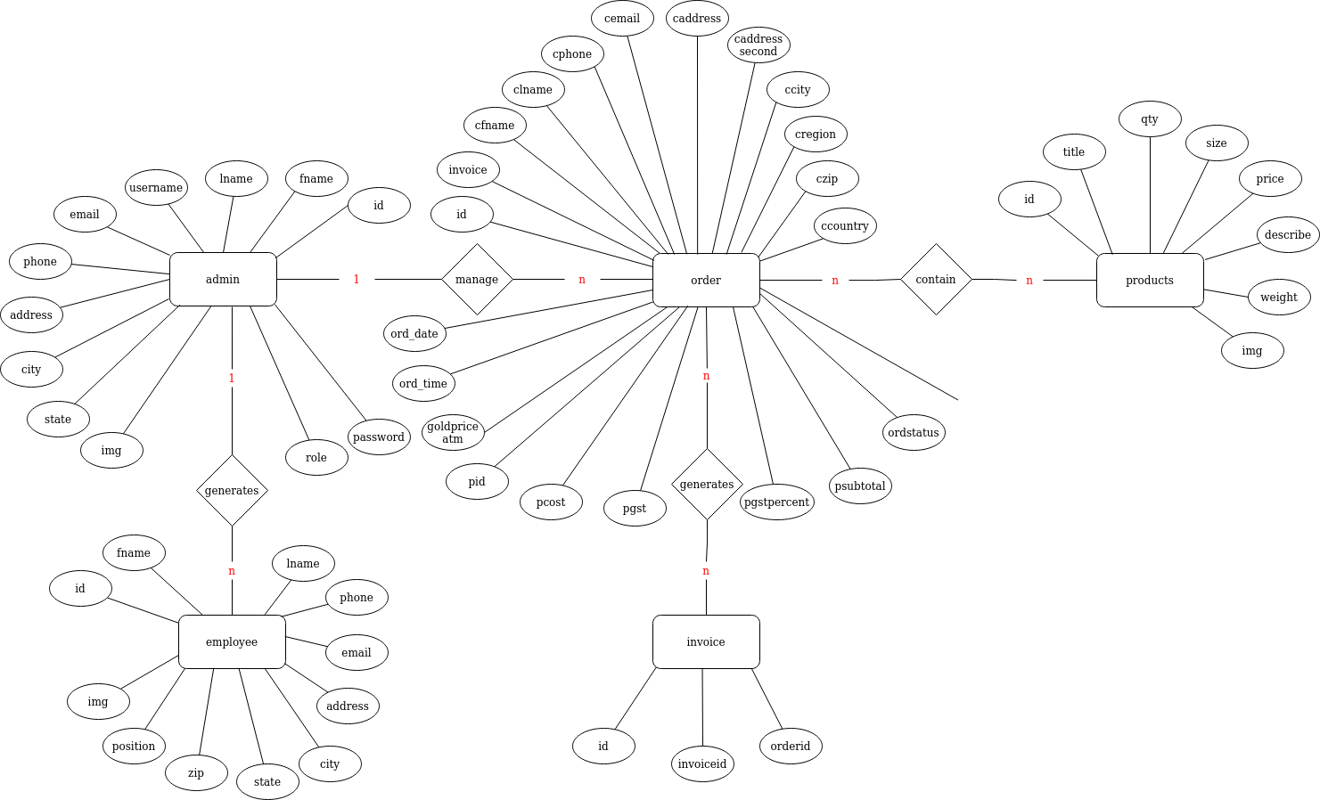

DFD (admin) :
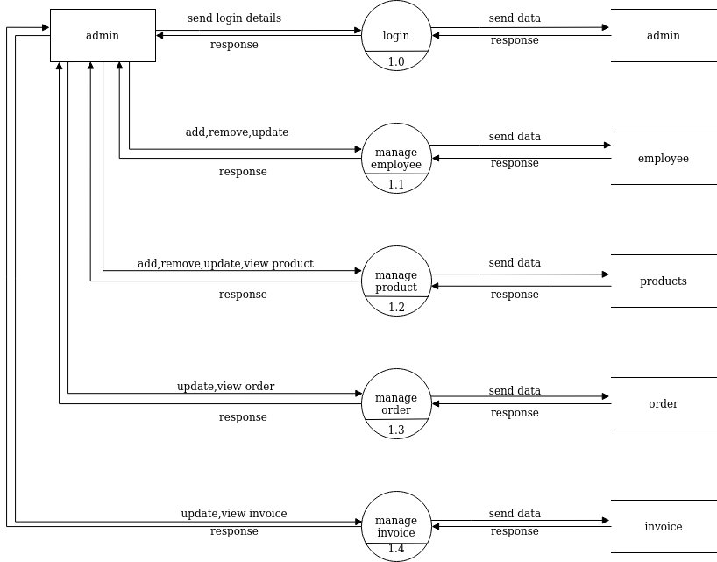

DFD(sales) :
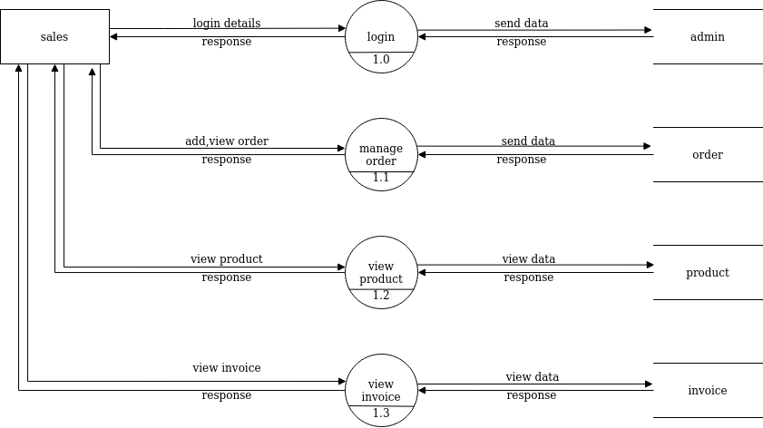
RELATIONAL MODEL :

SCREENSHOTS :
dashboard
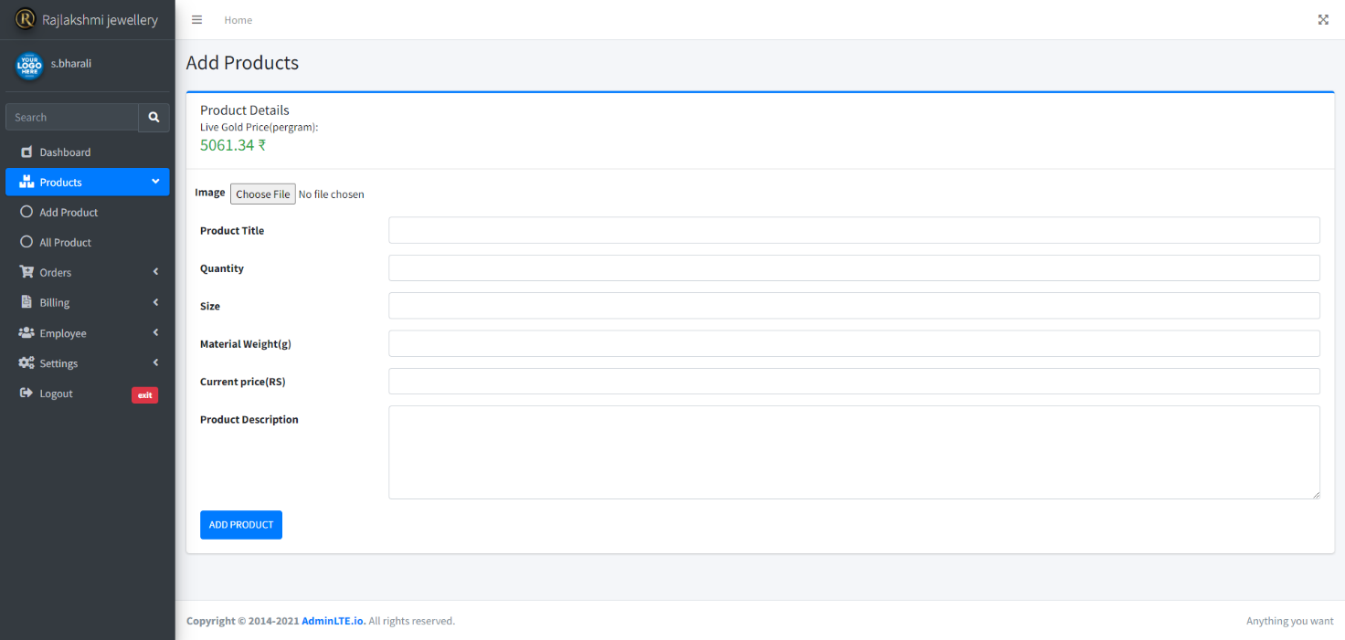
addproduct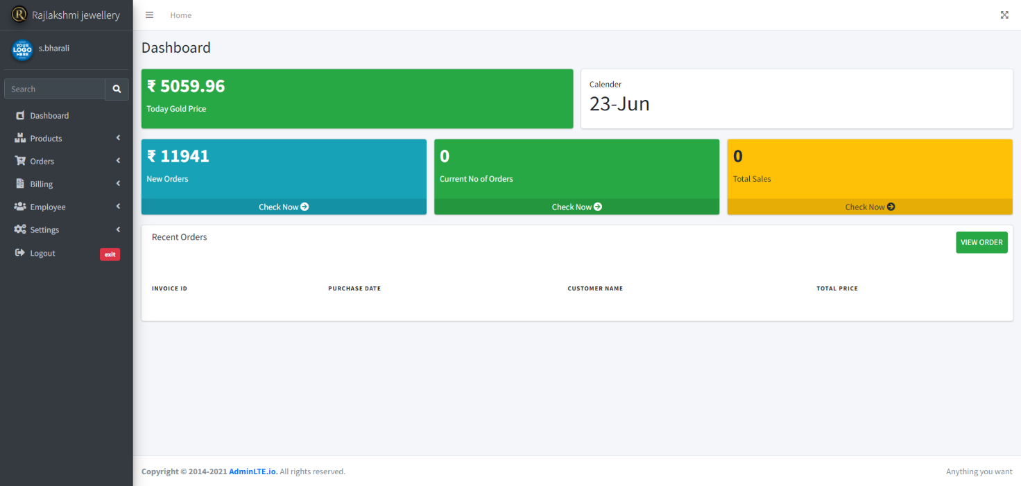
allproduct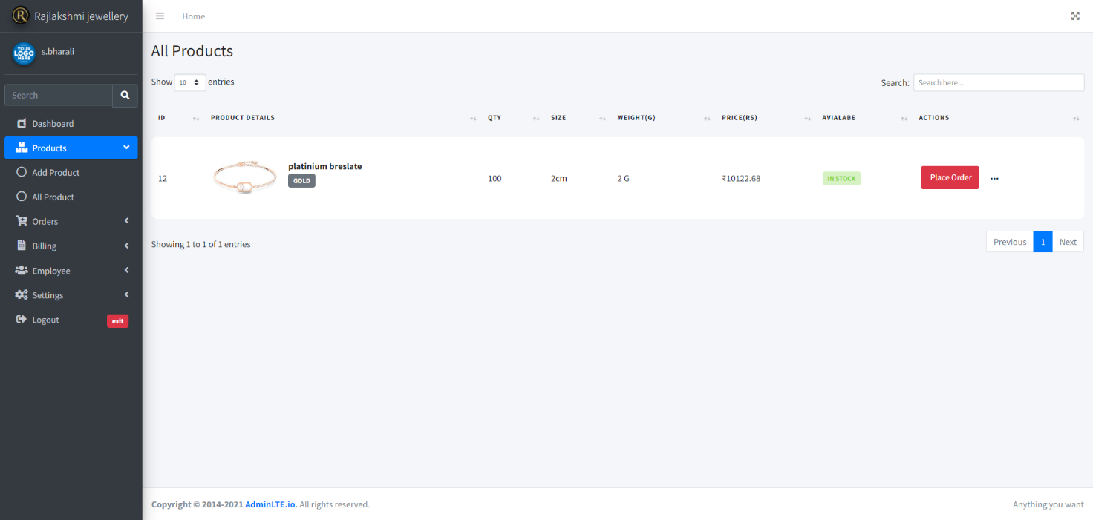

curent order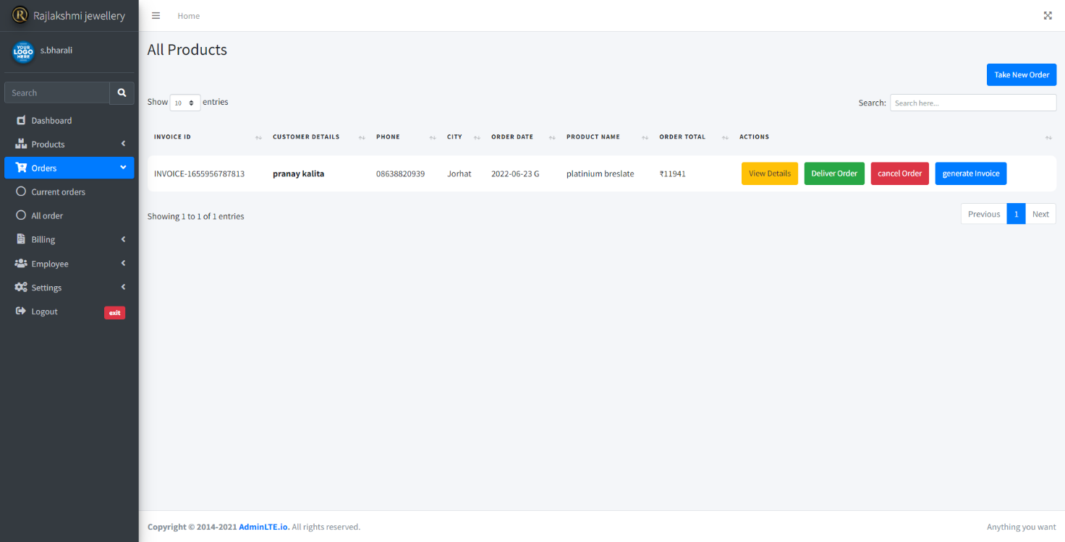
all ivoices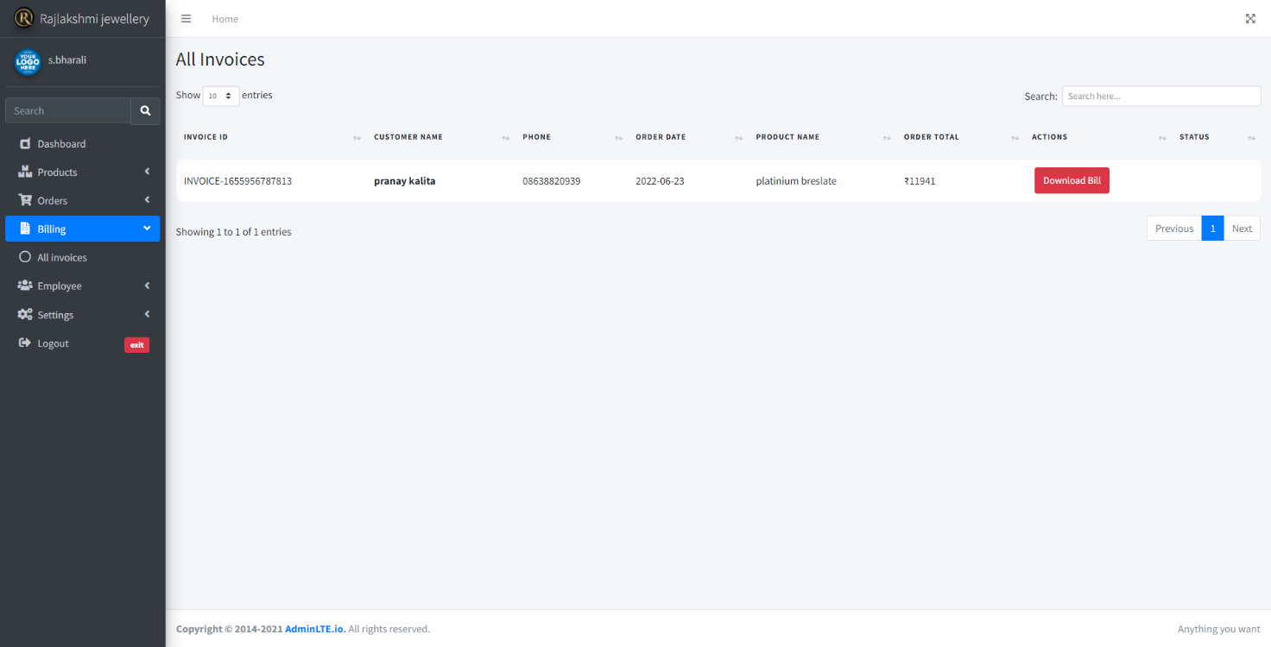

view product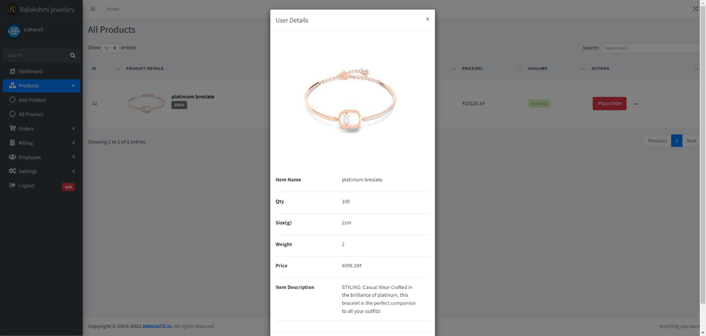
Take new order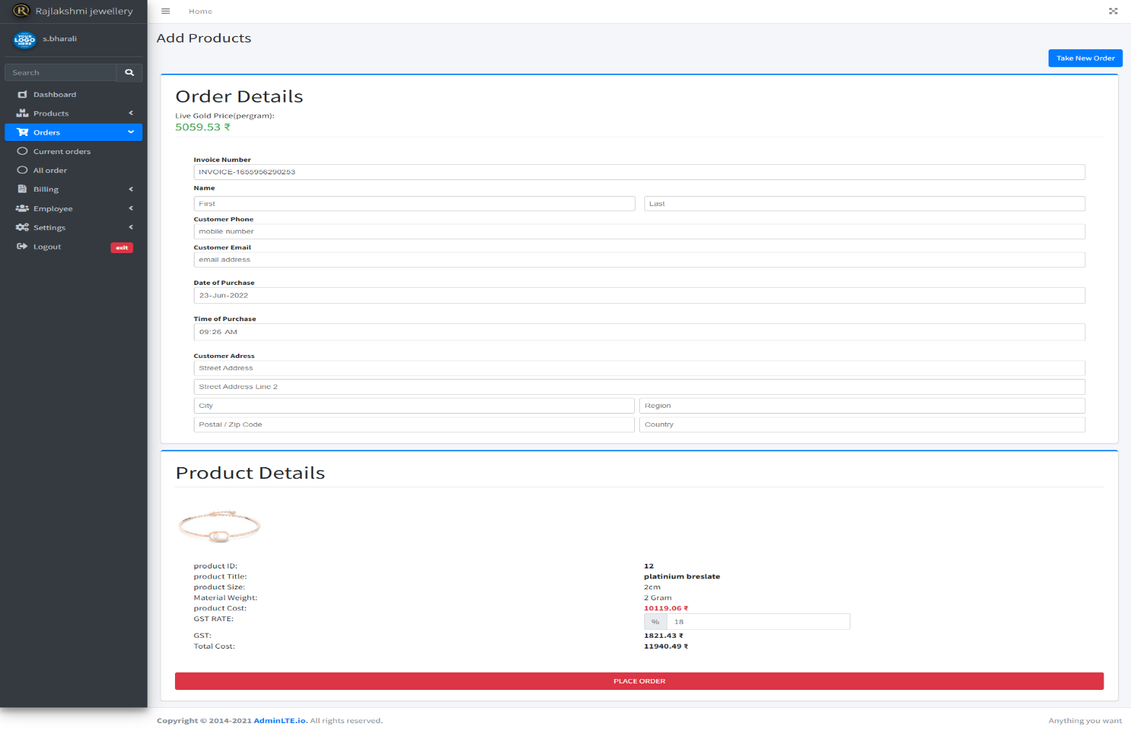
view order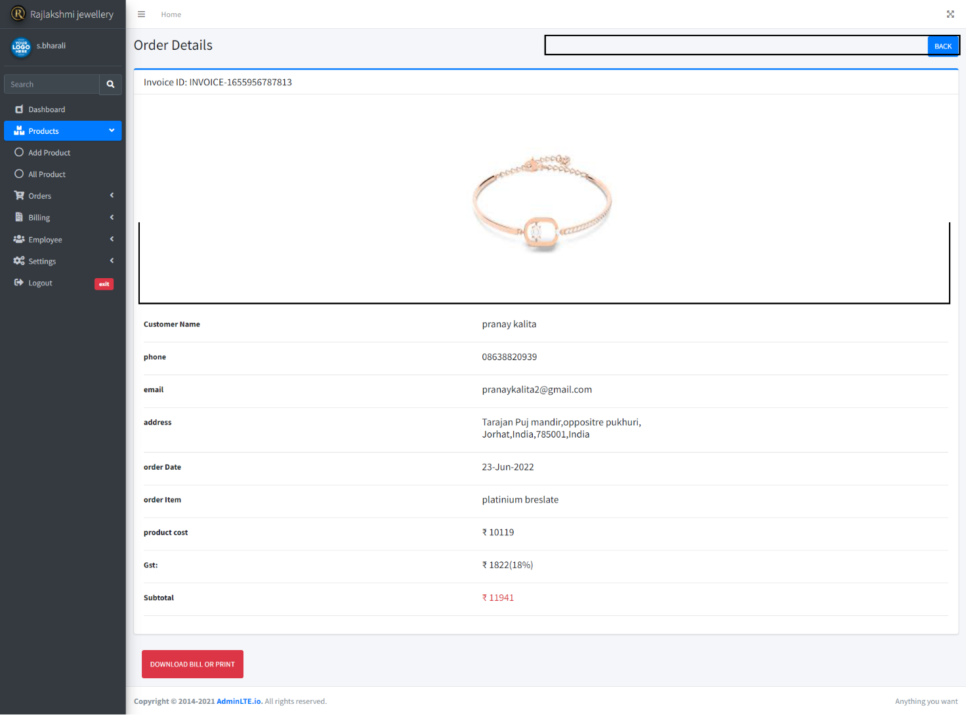
add employee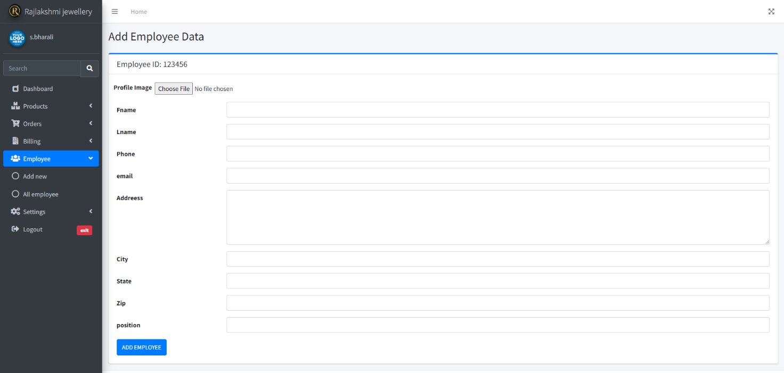

all employee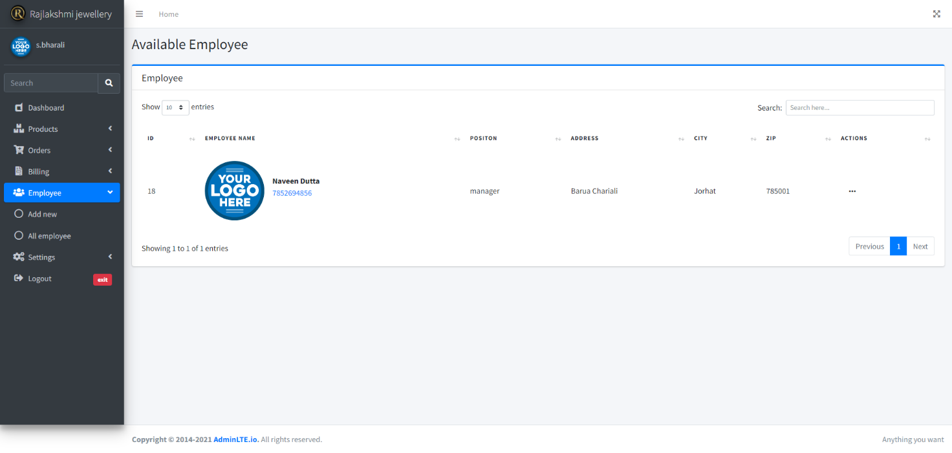
add user access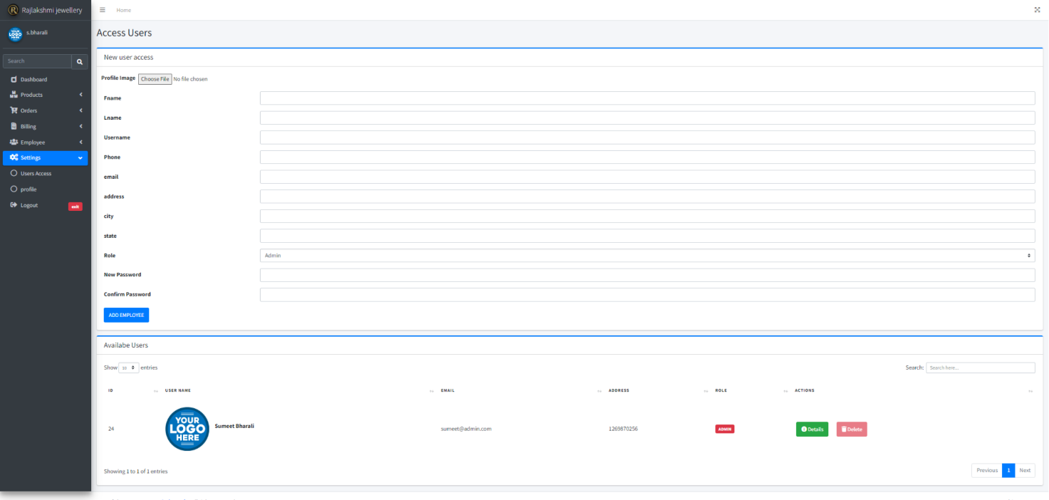

edit prodfile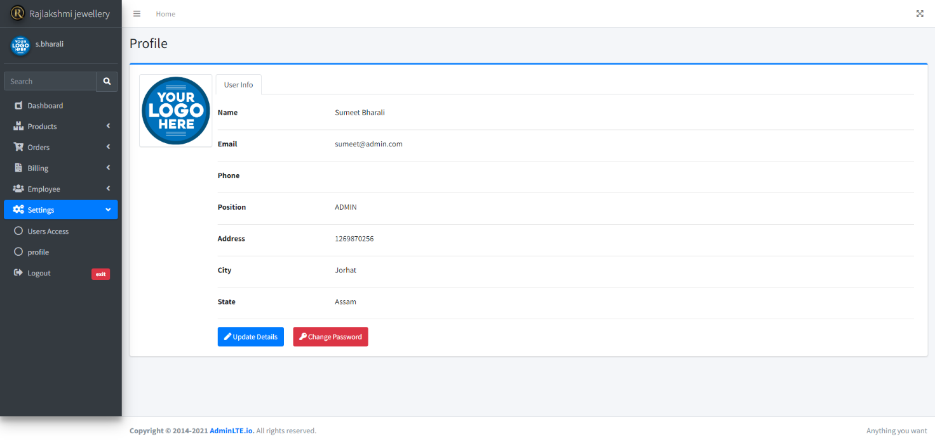

login page


TESTING :

- UNIT TESTING :
It focuses on the smallest unit of software design. In this, we test an individual unit or group of interrelated units. It is often done by the programmer by using sample input and observing its corresponding outputs.
- INTEGRATION TESTING :
The objective is to take unit-tested components and build a program structure that has been dictated by design. Integration testing is testing in which a group of components is combined to produce output.
- SYSTEM TESTING :
This software is tested such that it works fine for the different operating systems. It is covered under the black box testing technique. In this, we just focus on the required input and output without focusing on internal working.
- REGRESSION TESTING :
Every time a new module is added leads to changes in the program. This type of testing makes sure that the whole component works properly even after adding components to the complete program.
- SMOKE TESTING :
This test is done to make sure that the software under testing is ready or stable for further testing It is called a smoke test as the testing of an initial pass is done to check if it did not catch the fire or smoke in the initial switch on.
- PERFORMANCE TESTING :
It is designed to test the run-time performance of software within the context of an integrated system. It is used to test the speed and effectiveness of the program. It is also called load testing. In it we check, what is the performance of the system in the given load.

CONCLUSION :
The system “Jewellery Management system” deals with purchase and sales processing of a Jewellery shop. This system has been developed to satisfy all the proposed requirements. The process of recording details about supplier, item, Billing and customers is more simple and easy. The system reduces the possibility of errors to a great extent and maintains the data in an efficient manner. User friendliness is the unique feature of this system. The system generates the reports as and when required. The system is highly interactive and flexible for further enhancement.The coding is done in a simplified and easy to understandable manner so that other team trying to enhance the project can do so without facing much difficulty. The documentation will also assist in the process as it has also been carried out in a simplified and concise way.

BIBLIOGRAPHY :
- https://www.geeksforgeeks.org/
- https://stackoverflow.com/
- https://www.youtube.com/
- https://www.tutorialspoint.com/
- https://en.wikipedia.org/
- https://www.w3schools.com/

